Overview by Richard Huenink

Name | Death Valley Monster Truck Race
Filename | Map10.dnf
Size | Large
Setting | High Noon Hot

Level Summary
Description |  | Responding to orders Duke heads to Hoover Dam in an EDF Drop Ship to investigate a wormhole in the sky which is believed to be a portal from the Alien world. The Dam top is overrun with Alien forces so Duke is dropped off nearby and must drive his monster truck with a mounted missile launcher to make his way to the to the Dam.
Game Play Elements |  | Enemies  - Attack ships: Chase Duke, destroy the environment can be shot down with several missile hits  - Alien Drop ships: Deliver alien troops can be shot down with several missile hits  - Recon Bikes: Chase Duke can be run over with the truck or shot with missiles  - Pigcops: Can be run over with the truck or shot with missiles  - Assault Troopers: Can be run over with the truck or shot with missiles  - Assault Commanders: Destroy the environment. Can be shot down with several missile hits  - Giant Battle lord: Rises from lake mead at the Dam top can only be destroyed using Nukes  - Pigcops in vehicles: Ramming into the player and firing weapons  Destructible Items  - Small old wooden buildings: Out houses, tool sheds, cabins, mining sheds, old general stores etc. Can be smashed with truck or shot down with 1 missile hit  - Wooden Fences: Can be smashed with truck or shot down with 1 missile hit  - Wooden Road Blocks: Can be smashed with truck or shot down with 1 missile hit  - Wooden Pillars: Legs/Supports from bridges, railroad bridges, water towers, guard towers and piers. Break from running over them or 1 missile hit  - Signs: Billboards, road signs etc can be smashed with truck or shot down with 1 missile hit  - Jersey Barriers: Temporary highway dividers can be smashed with truck or shot with 1 missile  - Cactus, Joshua Trees: Can be smashed with truck or shot down with 1 missile hit  Puzzles and Stops  - Gas Cans: Run out of gas and solve navigation and physics puzzles locating gas cans  - Bridge: Locate and learn about gas cans acquiring a gas can in a small bridge guard building jumping through the skylight  - Mining Camp: Remove weight from an ore cart to push it up a hill. Use track switches to route the cart to the correct track and push it through a destructible barrier acquiring a gas can. Perhaps the player has to mount it and ride it over a broken track death pit. Another idea is to remove weight from a lift to solve a counterweight puzzle acquiring a gas can using David's old map07b counterweight puzzle  - Monster Truck Rally: Strength tap open a garage door and break shelving boards to acquire a gas can  - Wooden Pillars: Destroy legs from bridges, water towers and piers creating ramps  Explosive Items  - Vehicles: All vehicles cars, sedans, vans, trucks and buses explode but the bodies remain  - Red and yellow Barrels: Existing Red and yellow explosive barrels  - Propane Tanks: Existing red propane tanks  - Industrial Gas Tanks: Elevated industrial gas tanks used in farms and rural areas  - Gas Trucks: Explode completely clearing the path for really large explosion events  Moveable Items  - Cars: compacts and sedans can be pushed out of the way or go flying when struck with enough force. Have the same properties as exploding cars. Will blow up with 1 missile hit  - Small Boulders: Can be pushed or hit out of the way or go flying when hit with a missile  Barriers  - Cliffside Drop offs: The natural gorges will kill the player if he drives or jumps off  - Steep Rock walls: Steep high rock wall inclines of 60 degrees or greater  - Metal Fences: Metal reinforced fences cannot be moved or destroyed  - Metal Buildings: Metal reinforced buildings cannot be moved or destroyed  - Highway concrete dividers: Permanent highway dividers cannot be moved or destroyed  - Highway Metal Railings: Permanent highway railings cannot be moved or destroyed  - Large Vehicles: Vans, semi trucks and buses cannot be moved but explode the bodies remain

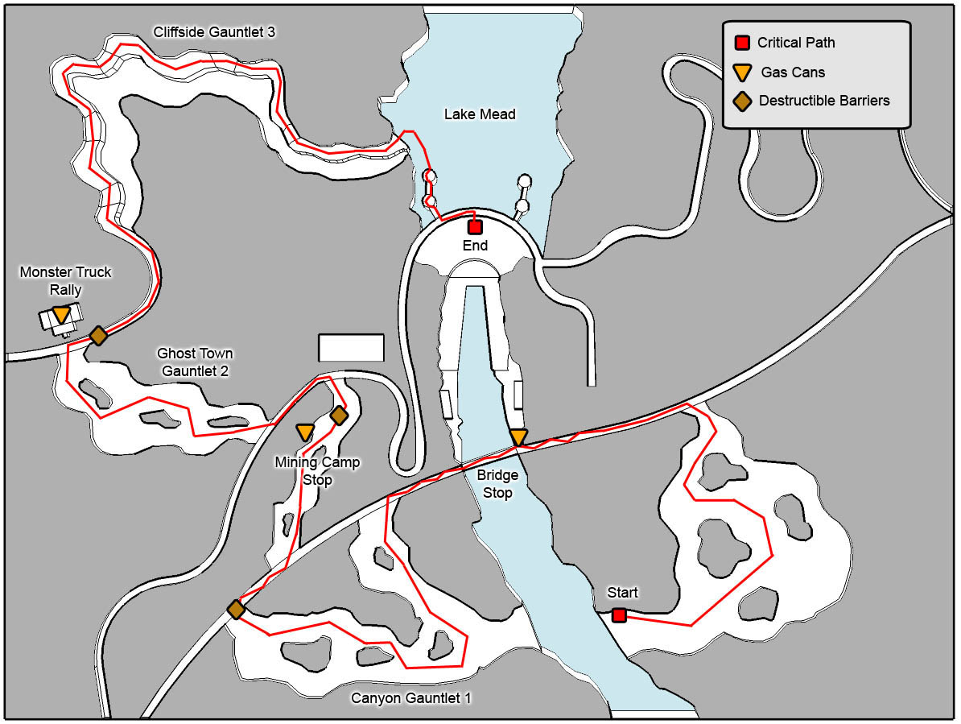

Walk Through | Intro Drop off  - Arrive at Hoover Dam and Drive the Monster Truck with a mounted missile launcher out of the EDF Drop Ship  - Explore while learning to Drive  - Bash through and crush a variety of enemies, vehicles and obstacles on a highway traffic jam gauntlet while avoiding civilians  Bridge Stop  - Run out of gas at bridge locate nearby gas can to progress  - Preview wormhole with Attack Ships coming out of it  - Drive across collapsing bridge as Alien Attack Ships destroy it  Canyon Gauntlet 1  - Smash through, run over and shoot down a variety of enemies and wooden obstacles on and off road while being pursued by Attack Ships  - Shoot down Alien Attack Ships with Truck turret  - Use the turret to Blow up an exit barrier to progress  Mining Camp Stop  - Run out of Gas at an abandoned mining camp  - Explore mining camp on foot solving a navigation/physics puzzle to acquire a Gas can  - Fight through an ambush to get back to truck  - Break wooden leg supports on a bridge creating a ramp to progress  Ghost Town Gauntlet 2  - Smash through, run over and shoot down a variety of enemies and wooden obstacles on and off road while driving through a ghost town  - Have an old west shootout with a pistol wielding Pigcop  - Use the turret to Blow up an exit barrier to progress  Monster Truck Rally Stop  - Run out of Gas at an a desert Monster Truck speedway  - Find gas can in garage solving navigation puzzle  - Return to truck with Gas can as Assault Commander turns other drivers into Pigcops  - Race against Pigcops that attempt to run over and shoot the player on a Monster Truck Track  - Jump into the final arena and win a demolition derby against Pigcop drivers  - NPC opens exit gate  Cliffside Gauntlet 3  - Drive across a treacherous Cliffside canyon road as Alien Attack Ships attack causing avalanches and destroying bridges in your path  - Make one last big jump landing in Lake Mead dismounting from Truck  Arrival at the Dam  - Swim to an intake tower finding an access ladder  - Reaching the Dam top a Giant Battlelord bursts out from Lake Mead  - Use 3 Nukes to destroy the Battlelord who collapses on an intake tower  - Rappel down the face of the Dam and smash through a vent to exit  .

