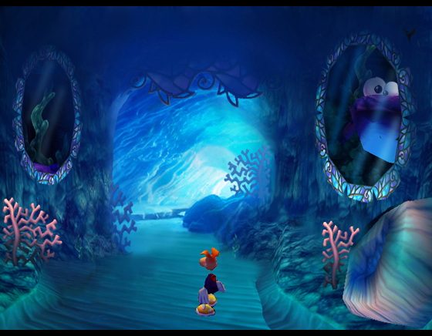 | RAYMAN M  Play tests - 2nd series Feedback  Software V.8.0 (10/07/01) | 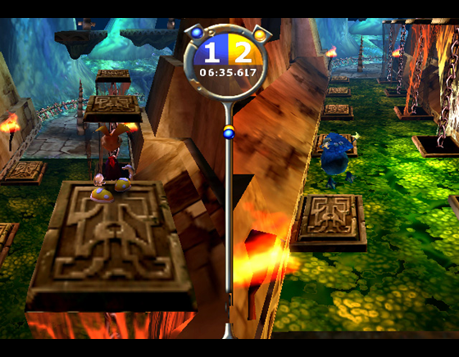

Introduction:

This document is the feedback on the 2nd series of Rayman M play tests.

Play tests objectives and methodology:

For this 2nd series of play tests, 4 sessions were planned to evaluate the game content, the controls, immediate handling, learning curves, fun content and to detect frustration areas on the last version (V8.0 – 10/07/01). The main changes are linked to the increase of the characters speed in the Racing part, and an improved game play in the Fighting part.
Most elements were checked with direct observations, time recording, and a few questions were asked after each game sessions about the players general feelings. We focused the methodology on objective and measurable observations, in order to obtain sure and useful information, to provide the production studios with.

8 players in total, selected according to the game target, have played the game in normal conditions.
Each session lasted 2 hours (1h focused on Rayman Tribe, 1h on Shooting Fish) and had its own game planning, to enable us to test immediate handling and various features, in the single and multiplayer modes.

8 Testers profile:

- age:  - 8-10: 1 player  - 10-12: 2 players  - 13-15: 5 players | - play time per week:  - 2 to 10h/week: 4 players  - 10 to 20h/week: 2 players  - more than 20h/week: 2 players
- sex:  - male: 8 players | - players favourite games:  - Mario Kart, F Zero, Crash Bandicoot  - Need for speed  - SF Turbo, Tekken III  - Yannick Noah, Roland Garros  - ISS, FIFA  - Starcraft, Counterstrike
- hardware owned:
  - PlayStation X: 5 players
  - PC: 4 players
  - Nintendo 64: 4 players
  - PS2: 1
  - Dreamcast: 0
  - GBC: 1
  - GBA: 3

All suggestions are only free proposals and should not be taken as commands or even advices… We don’t want to point out a problem without proposing a solution.

I ) The menu interface:

We asked the players to access to the games by themselves saying: “play a new game, choose First Ruins track in challenge mode and select Race” we then observed how they find their way across the menus and we detected hesitations (and spontaneous comments/questions) on each menu sequences.

    - a few players had hesitations on their first game, because the numeric pad of the Dualshock does not work in the menus.

    - 8/8 players could easily navigate through the menu since their 2nd try

    - 8/8 players found the interface very attractive.

    - 1/8 players did not notice he could skip the “tunnel transition” pressing X and said he felt the menu sequence was a bit long.

 | - the menus look great and are very easy to use  - a visual indication could tell the player he needs to use the analog stick

II ) Race Mode

1 ) Learning curves

A ) Time scores

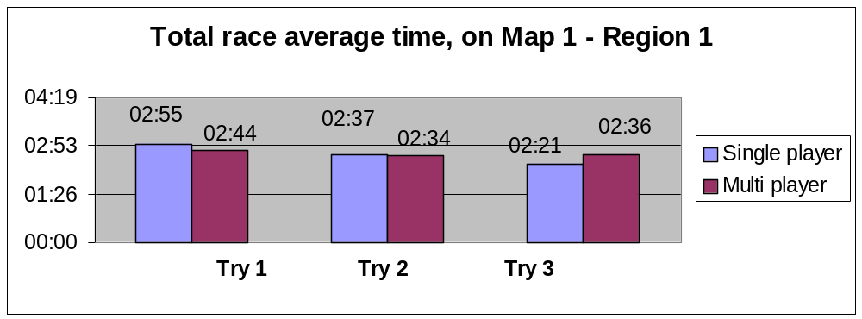

In both single and multiplayer modes, all players improve their time with practice, which means they understand the challenge and the way they can win. The learning is a bit faster in single mode because the players are not disturbed by the other player actions and because the race visibility is better (full screen).

On the other hand the first race is easier in multiplayer because the players can look at the other half screen to get tips about short cuts and various trajectories.

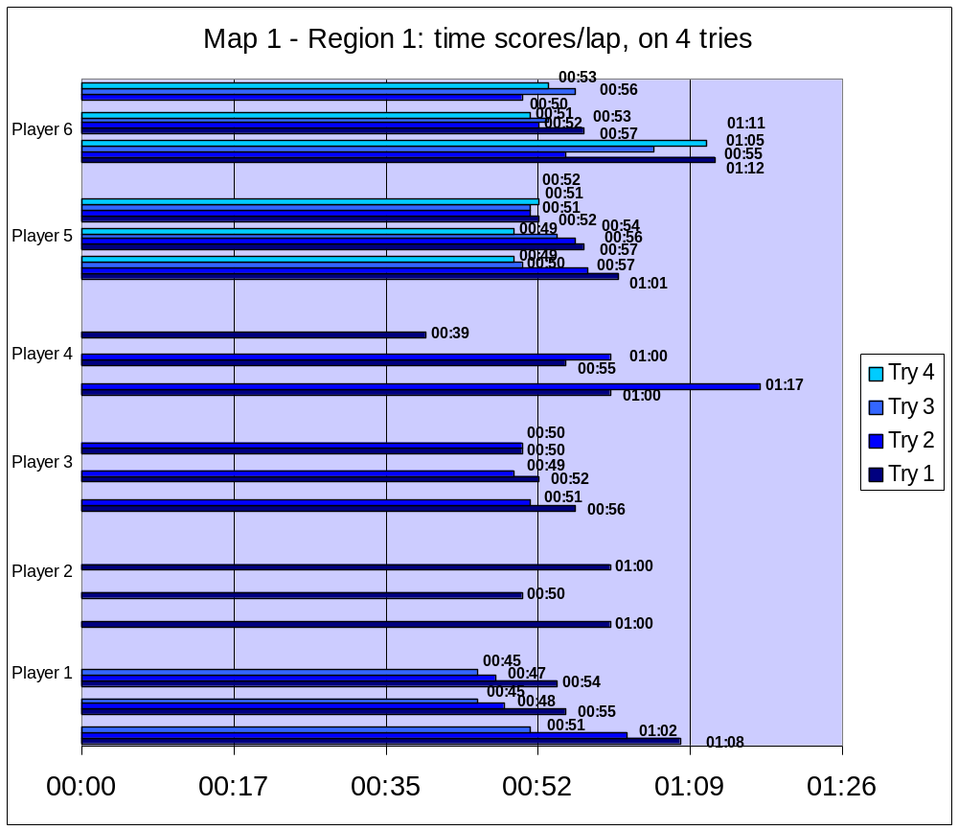

All players globally improved their time with practice (but player 6 who had a particular profile and was not used to Playstation or PS2 games).
The average time for their last try on Map 1 – Region 1 is 49 secs, which is fairly good.
The learning curves on this map (first map tested in the game) is satisfying: it proves that the players understand the objective, the challenge and know how to correct their errors.

Player 6, who had a different gamer profile (no gaming experience on Playstation), did not improve his time on first laps, but he needed his 3 laps on each try to reach a good score.
Anyway, all players succeeded to perform a lap time shorter than 50 secs on 2nd or 63rd try.
The 1st map is a good training track.
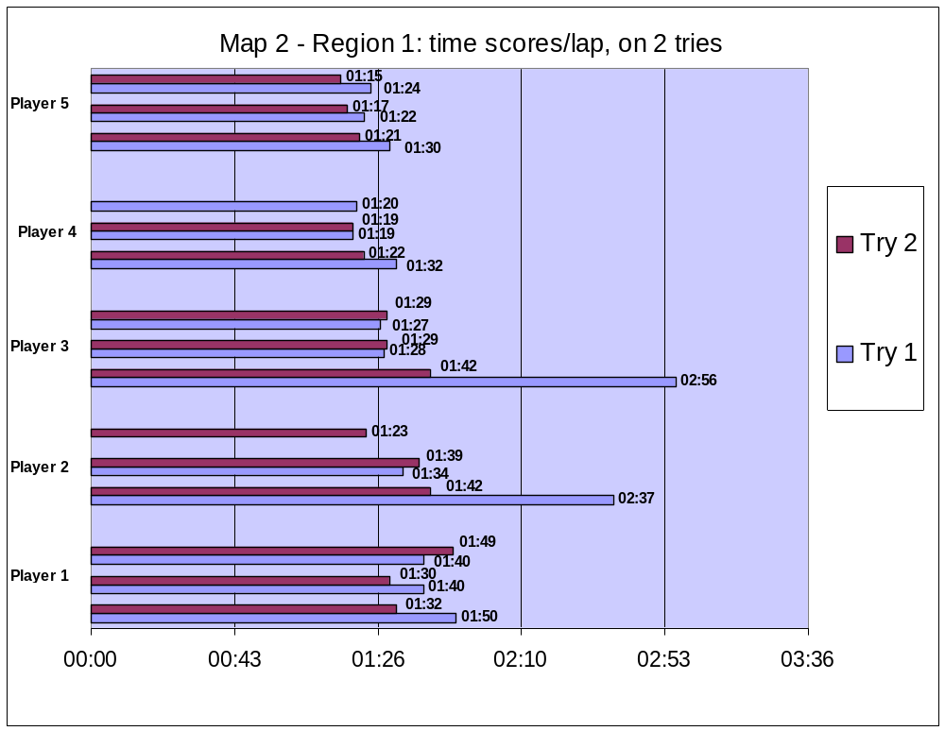
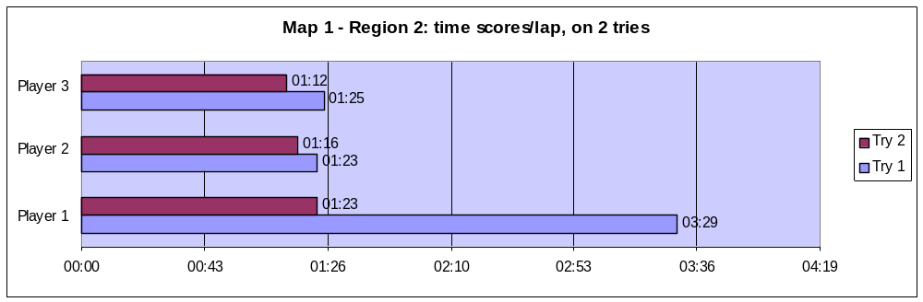

- All time records are about 30% faster than previous version.
As the character speed was increased by 30%, it shows that this new game play did not generate any bad effect in visibility, or general difficulty.

- All players improved their time records with practice, on all maps tested.
The learning curve is regular: the players understand the challenge, the controls and find an interest in going faster.

- The first lap also becomes a “discovery lap”, before trying to perform a time record.

B ) Pafs evolutions

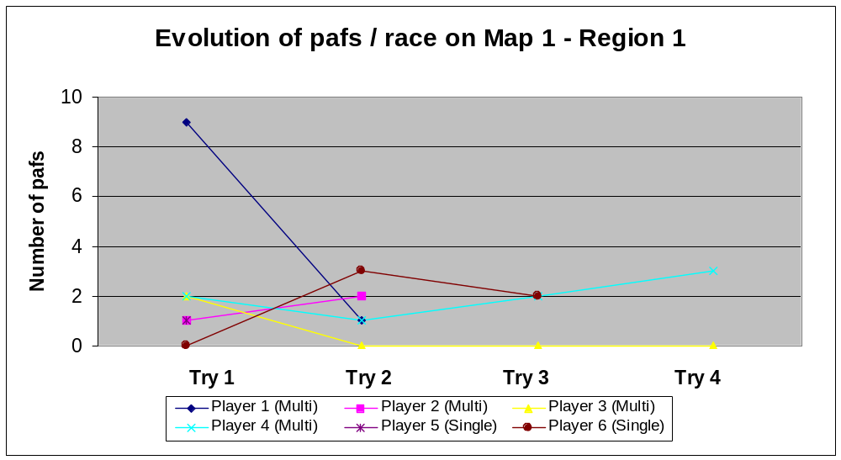

One paf is counted every time the player hits an element in the map that stuns him and slowers him: walls, roots, lasers, fences, etc… A part of the fun in the race depends on a clever slalom of these traps, but too much “pafs” shows a possible area of frustration and a necessary map design tuning.

After 2 tries, all player have lowered their collision to 3 pafs max in the whole race. Both single and multiplayer modes show a very good evolution of pafs/laps, which means that the players improve their skills to avoid traps with practice. They understand the obstacles and learn to avoid them.

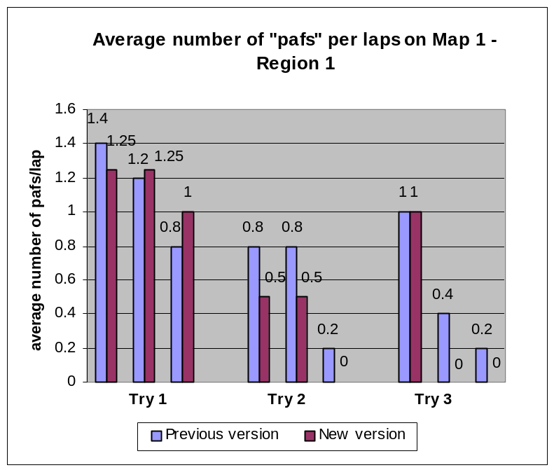 | The collision learning curve seems faster with the faster game play.  The players need to concentrate more on the trajectory with a fast character. They will then not use switches or short cuts but focus on avoiding obstacles.

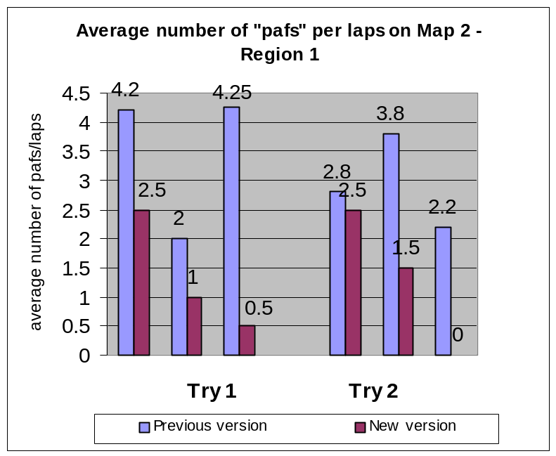 |  |  | Same observation on Map 2 – Region 1.  Players had less pafs with new version, and a faster learning of the obstacles.  The stats underneath confirm that with the new race speed, the players will rather focus on trajectories and traps avoiding because the feeling of “wasted time” is increased.  For the same reasons they will very rarely try new parts of the tracks, buttons, or pink rings.
 |  | Previous version |  | New version
 | Players who shot at some switches  (at least once) | - 12/15 (80%) of the players |  | - 3/8 (37%) of the players
 | Players who used switches efficiently | - 5/15 (33%) of the players |  | - 2/8 (22%) of the players
 | Players who used the pink rings  (at least once) | - 3/15 (20%) of the players |  | - 1/8 (11%) of the players

Pafs stats per maps:
 |  |  | Previous version | New version
 |  |  | Map 1 Region 1
 | best “pafs” per lap |  | 0 | Single: 0 - Multi: 0
 | worst “pafs” per lap |  | 3 | Single: 3 - Multi: 3
 | average “pafs” per lap |  | 0,76 | Single: 0.5 - Multi: 0.63
 |  |  | Map 2 Region 1
 | best “pafs” per lap |  | 0 | 0
 | worst “pafs” per lap |  | 8 | 2
 | average “pafs” per lap |  | 3,17 | 1
 |  |  | Map 3 Region 1
 | best “pafs” per lap |  | 2 | 5
 | worst “pafs” per lap |  | 8 | 6
 | average “pafs” per lap |  | 4,38 | 5.3
 |  |  | Map 1 Region 2
 | best “pafs” per lap |  |  | Single: 0 - Multi: 0
 | worst “pafs” per lap |  |  | Single: 5 - Multi: 5
 | average “pafs” per lap |  |  | Single: 1.5 - Multi: 1.3
 |  | - The average collision learning curve is better than before, and the average number of pafs is lower, which should generate fewer frustrations on first games.  - The speed effect is better perceived by the player.  - With the new race speed, the players focus on trajectories and traps avoiding rather than try different game play (new parts of the tracks, buttons, or pink rings) because of an increased feeling of “wasted time”. The game play might become more repetitive.
2 ) Competition appeal – Position swaps.

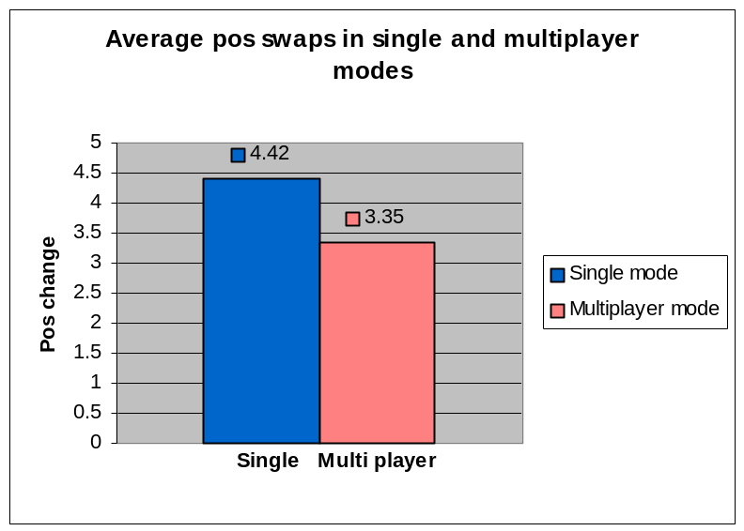

In single mode, the average number of position changes is faked by the fact that the bots got stuck on the map. As 80 % of the players could not chase the bots in medium level (V. 8.0), the only way to pass them was when they were stuck.

In multiplayer mode, the 3.35 average number of swaps could still be improved. The next series of tests will report more detail about competition (ex: can the leader always get caught up by the second).

 | Previous version | New version
 | In single player, versus bots:
Minimum  (after 1 hour of game play) | 0 swaps, on 56 % of the races | 0 swaps, on 22 % of the races
More than 3 pos swaps | in 18 % of the races | in 22 % of the races
More than 6 pos swaps | in 7 % of the races | in 22 % of the races
Maximum | 9 swaps | 9 swaps
Average | 2 pos. swaps / race | 3 pos. swaps / race
 | In multiplayer:
Minimum  (after 1 hour of game play) | 0 swaps, on 25 % of the races | 0 swaps, on 8 % of the races
More than 3 pos swaps | in 58 % of the races | in 41 % of the races
More than 6 pos swaps | in 17 % of the races | in 16 % of the races
Maximum | 10 swaps | 11 swaps
Average | 4 pos. swaps / race | 3 pos. swaps / race

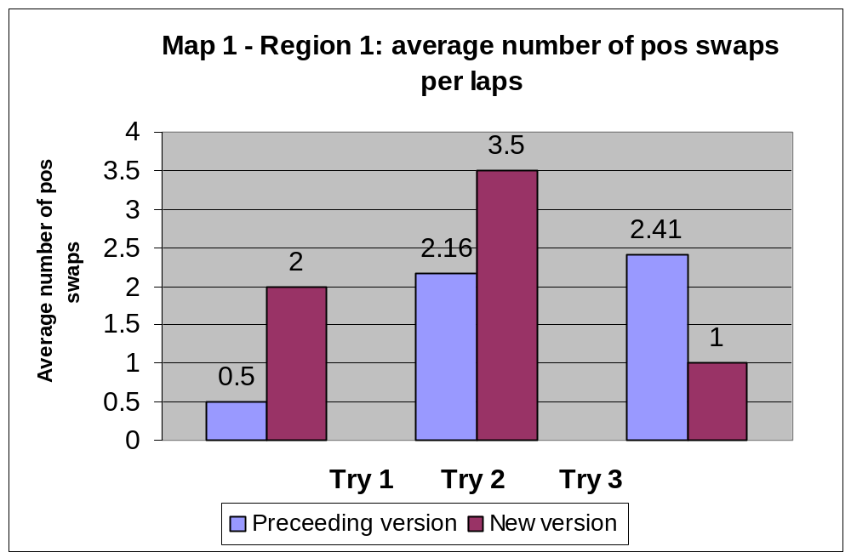
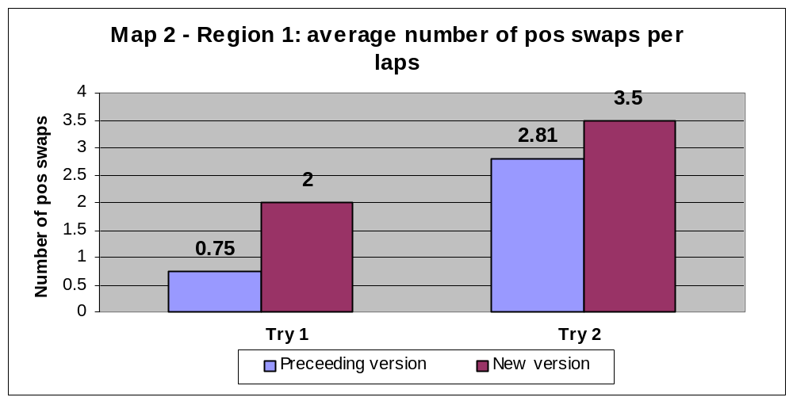

- In multiplayer, the new version of the race mode clearly generates more position changes and more competition. A “0 position swaps” situation (meaning that the competitor is too far away to be ever caught up again) becomes quite unusual.

- In single player, during normal race conditions (i.e.: when the bots behaviour is not bugged), the competition appeal is much better. It’s very uncommon to be distanced by all the bots after 3 tries on same map.

- The competition with the bots is still to be analysed, as their AI was not developed enough: they still kept stuck on various parts of all maps (ex: permanently hit by the plants in the stairs of map 2, stuck in tower stairs, cf. video footage) and were then easy to pass.

Observation summary and suggestions:

- The menus look great and are very easy to use
Suggestion: A visual indication could tell the player he has to use the analog stick to make his selections.

- All time records are about 30% faster than previous version.
As the character speed was increased by 30%, it shows that this new game play did not generate any bad effect in visibility, or general difficulty.

- All players improved their time records with practice, on all maps tested.
The learning curve is regular: the players understand the challenge, the controls and find an interest in going faster.

- The average collision learning curve is better than before, and the average number of pafs is lower, which should generate fewer frustrations on first games.

- The speed effect is better perceived by the players.

- In multiplayer, the new version of the race mode clearly generates more position changes and more competition. A “0 position swaps” situation (meaning that the competitor is too far away to be ever caught up again) becomes quite rare.

- In single player, during normal race conditions (i.e.: when the bots behaviour is not bugged), the competition appeal is much better. It’s very unusual to be distanced by all the bots after 3 tries on same map.

- With the new race speed, the players focus on trajectories and traps avoiding rather than trying different game play (new parts of the tracks, buttons, or pink rings) because of an increased feeling of “wasted time”. The game play might become more repetitive.
Suggestion: with the faster game play, buttons, rings, slide sections must still be attractive to the players. As they are more difficult to use with the new speed, their positions should be adapted in the first maps for a very easy access. When the players have discovered the real added value of the various game play (short cuts, platforms, pink rings), they will try to use them even in difficult access (on advanced maps).

- The competition with the bots is still to be analysed, as their AI was not developed enough: they still kept stuck on various parts of all maps (ex: permanently hit by the plants in the stairs of map 2, stuck in tower stairs, cf. video footage) and were then easy to pass.
Suggestion: the 3rd series of tests (results to be provided on the 7th of August), will focus on the Bots AI adaptation.

- in Map 2 – Region 1 (Nebulous tower), some players could not find the way up the tower and kept running around (they don’t see the climbing zones despite the arrows).
Suggestion: add a low jump bumper under the climbing zone, to show them the way.

II ) Shoot Mode

1 ) Immediate handling (play time = 0 to 10 mins)

This section contains observations, as no explanations about objectives, controls, or game play were given to the players, during 10 mins.

    - 8/8 players used the correct minimum controls (run, jump, shoot).

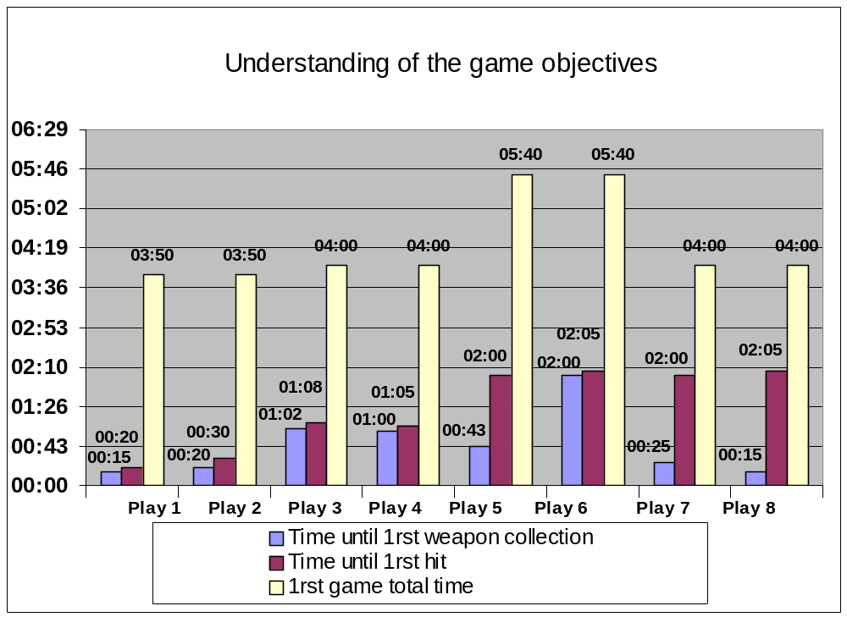

- The average length of the first game was reduced, the first fights are now more intense.

- 5/8 players managed to hit the enemy in less than 10 secs after first weapon collection.

- 2 players (3 and 4) kept running across the map without understanding the objective of the fight game. Player 6 did not collect a weapon for 2 mins on first game.

- players 7 and 8 kept on shooting at each other without hitting for 2 mins.

2 ) Advanced gameplay (play time = 10 to 60 mins)

After 10 mins of gameplay, the controls, game objectives and the characters aptitudes (equivalent of manual content) are explained to the players, but we don’t show them in the game and let them discover the new elements.

Map design:

- 8/8 players could easily find the enemy.
- 8/8 players could chase the enemy.
- most players did comments on the maps beauty (especially the moonlight one).
- no comments were done about dark or unclear zones as for previous maps.

Controls :

The lock system was improved, which generated more far distance shoots and less close combat chaotic fights.
- 0/8 used the 2nd analog stick for precise aiming (too hard and too slow).
- the auto-aim feature was mostly appreciated.
- the camera moves were much improved.

Weapons :

Unfortunately, we did not have the weapon “in-game stats” to give more details about weapon use and efficiency. Anyway we noticed that:

- the players would rather shoot their ammos than drop an unwanted weapon.
- the bomb is the favourite weapon and generates a lot of fun (more players spontaneously understood they could give it back.
- the “weapon stealer” is not understood.
- the players try to kill with the shield.
- they don’t look at the ammo counter but reload when the fire buttons makes punches.

Games length :
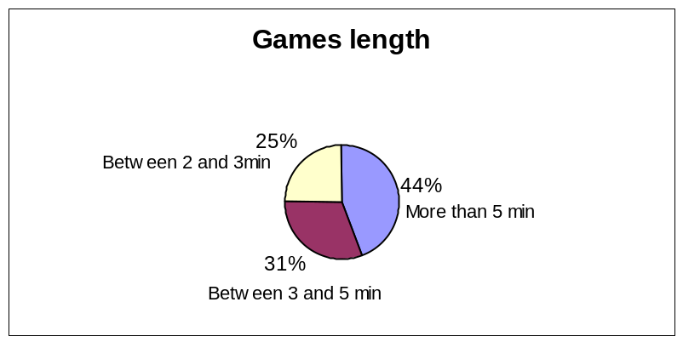

The average length of games is still long but was much improved, particularly by the auto-aim modifications and the lock button, that allows the players to hit more often.

The fact that the time limit was removed is a good point. It’s a better feeling to kill the enemy by taking all his life points, even with more time.

Multiplayer competition, Game balance :

 | Session 1 | Session 2 | Session 3 | Session 4
Scores | 7-0 12-0  8-0 3-0  0-13 1-0 | 0-7 0-7  6-0 | 7-0 0-1  0-11 1-0  0-9 | 17-0 13-0  0-8 3-0  5-0
Games won | 5/0 | 2/0 | 2/3 | 4/1
Average number of points sharing | 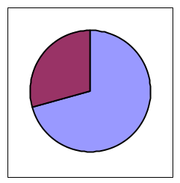 | 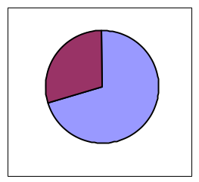 | 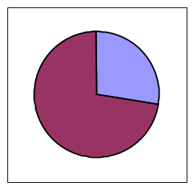 | 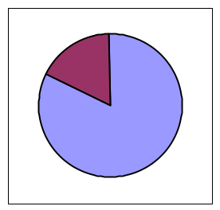

The scores seem a bit less balanced than before. The easier aiming system and the increased the weapons efficiency may fasten the fights and the dominations. The loosing player has less time to come back on the score.
This result needs to be confirmed on further play tests, as only 8 players tested the game for this series, and as the balance depends on the players skills which were more various than for the previous tests.
Anyway, we did not observe any total domination, nor major frustration by the loosing players.

Observation summary and suggestions:

- Good immediate handling: minimums controls (run, jump, shoot) are obvious for all players.

- The average length of the first game was reduced, the first fights are now more intense.

- The auto-aim feature was mostly appreciated: 5/8 players managed to hit the enemy in less than 10 secs after first weapon collection.

- The camera moves were much improved.

- All maps are very clear and attractive.

- The bomb weapon is a great moment of fun.

- All games now finish on a total kill, rather than a time limit (accomplishment feeling is improved).

- The auto-aim feature was mostly appreciated.

- The camera moves were much improved.

- 2 players kept running across the map without understanding they had to shoot at each other. Player 6 did not collect a weapon for 2 mins on first game.
Suggestions: a short cinematic (or an Hi-Res picture on loading screen) could show a fight sequence before first match. It can only be a sort of screenshot showing a character dodging the enemy bullet.

- The fights are still a bit chaotic, players shoot all ammos roughly in the enemy direction rather than play tactical moves. It might be caused by the game discovery (players only try 6 or 7 games at the best during a session).

- The 2nd analog stick is not adapted for a fast pace match.
Suggestions: a well tuned auto-aim (you automatically aim the character in your line of fire) seem more adapted than a precise aiming devise.

- The “weapon stealer” is not understood.
Suggestions: the visual “stealing effect” is not obvious enough. Can the stolen weapon icon rush from victim to the stealer with the flash effect?

For any further information, comments or details about these play tests, please contact me:

Lionel Raynaud  Games analyst  Games Lab  Tel.: 00 33 (0)1 48 18 55 90  Cell. : 00 33 (0)6 63 45 78 20  Fax.: 00 33 (0)1 48 18 59 74  lraynaud@ubisoft.fr | Ubi World Studios  28, rue Armand Carrel  93 108 Montreuil sous Bois Cedex  France

